Below minor functionality for Phase-1 Extension

**Refine Search(All sub-domain)**

* + By Landmark ( Only Daycare)
  + Rating
  + Recommendation
  + Admission Type: off-line/on-line/entrance test
  + Facilities
  + By state (Only College)
  + By Entrance Exam (Only College)
  + By Duration (Only College)
  + By Type of college( Private, Public)(Only College)
  + By Course Type(Degree, Diploma, Certificate, Distance etc) (Only College)
  + By Type of course( Full time, part-time, distance, Online) (Only College)
  + By Fee (Only College)

**All sub-domain**

1. **Search Bar re-design like Housing.com**

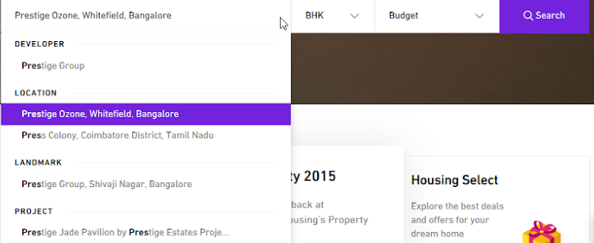

1. **Info page** 
   * + New Tab for Placement , Fee , Faculty**(only College)**
     + New Tab for Excellence/Achievement , Fee , Faculty**(only School)**
2. **Ask Question**

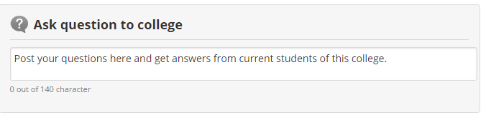

1. **Add to Wish List**
2. **iDiksha Ratings like below on Info Page & Analytics**



**iDiksha Analytics Display on Info Page.**

* This information was last updated on 23/11/2015.
* 5069 students have downloaded brochure.
* Courses have been viewed 2084 times.

1. **Get contact details on SMS Info Page & Realign Address bar.**

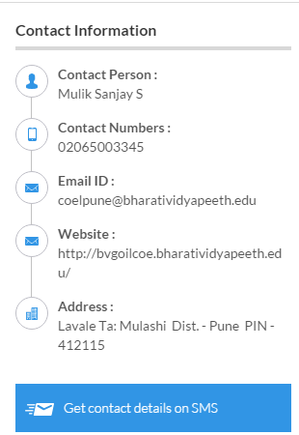

1. **Want to suggest Edit**



1. **Face Book Promotion design like below on Info Page.**

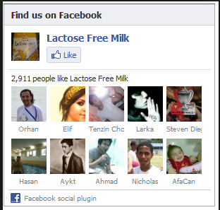

1. **Link to Discussion forum thread**

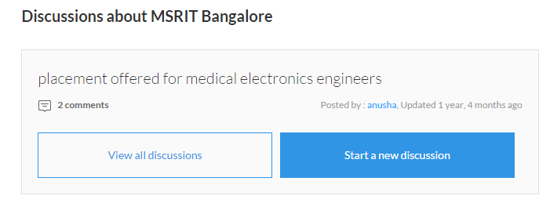

1. **Similar/Nearby Sub-domain**

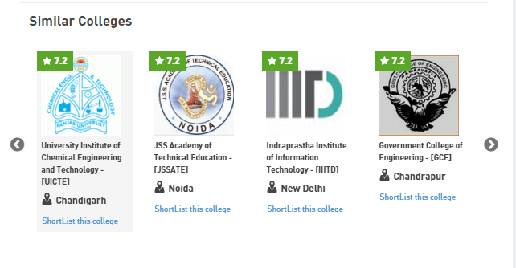

* + Nearby sub-domain

